Chapter 9, Problem 91.

Figure 9.91 shows a parallel combination of an inductance and a resistance. If it is desired to connect a capacitor in series with the parallel combination such that the net impedance is resistive at 10 MHz, what is the required value of C?
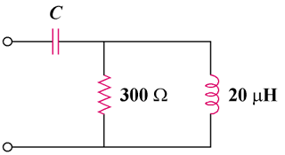

Figure 9.91
For Prob. 9.91.

